DAY 6

CLASS EXERCISE 1

POST MAPPING

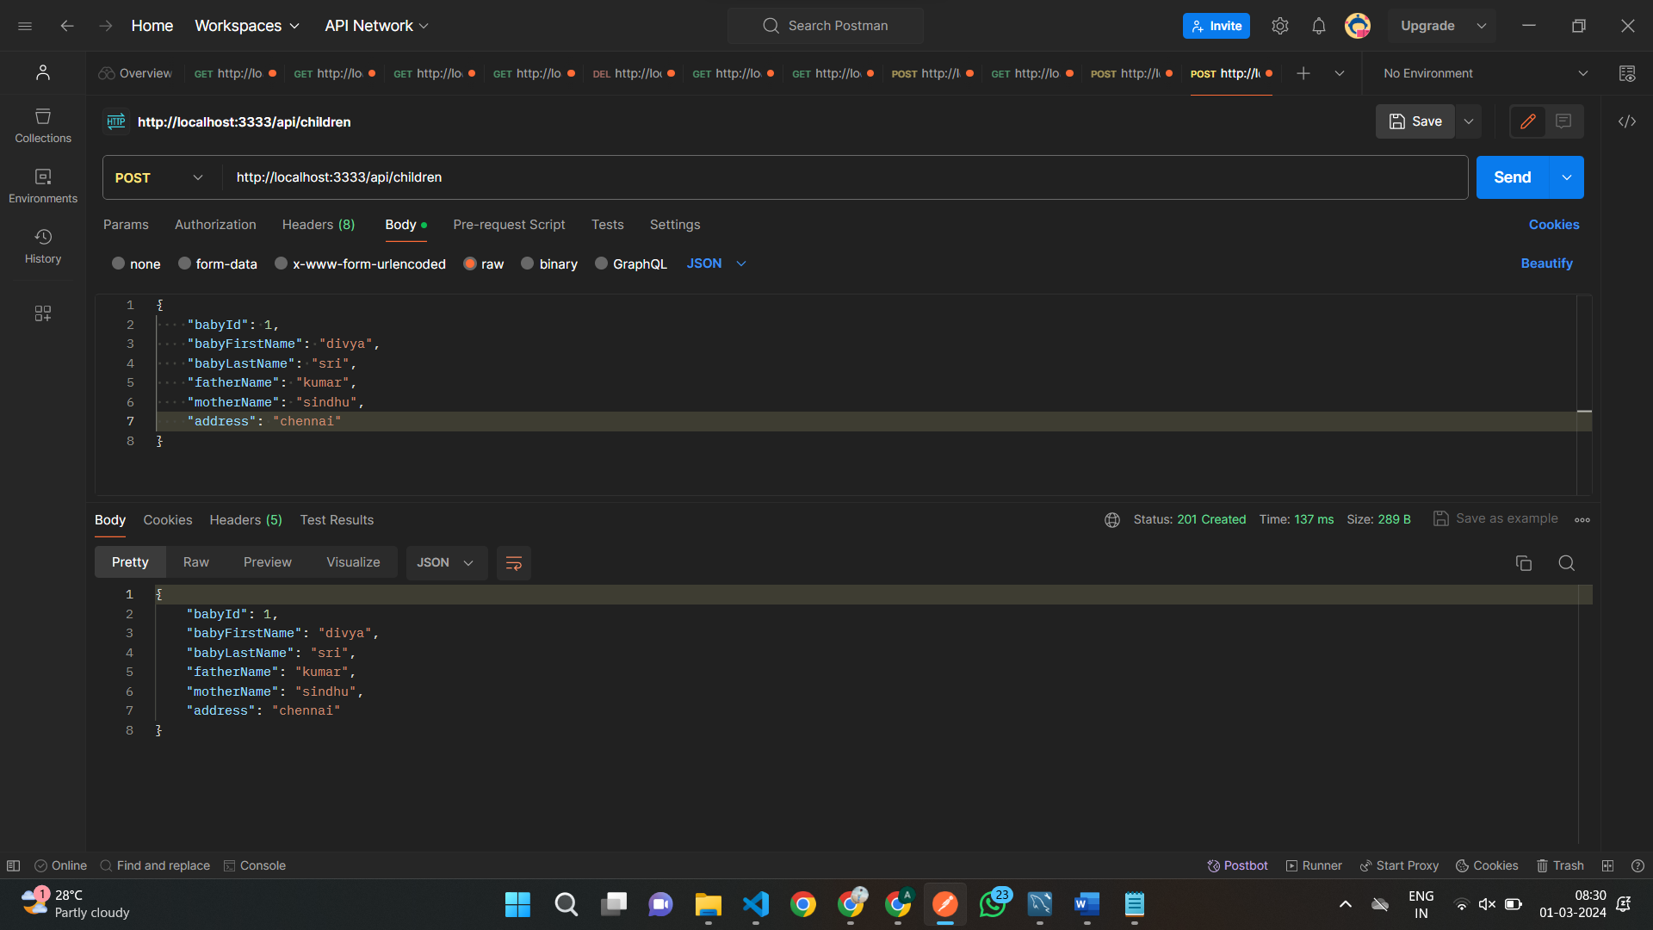

GET MAPPING by sort by lastName

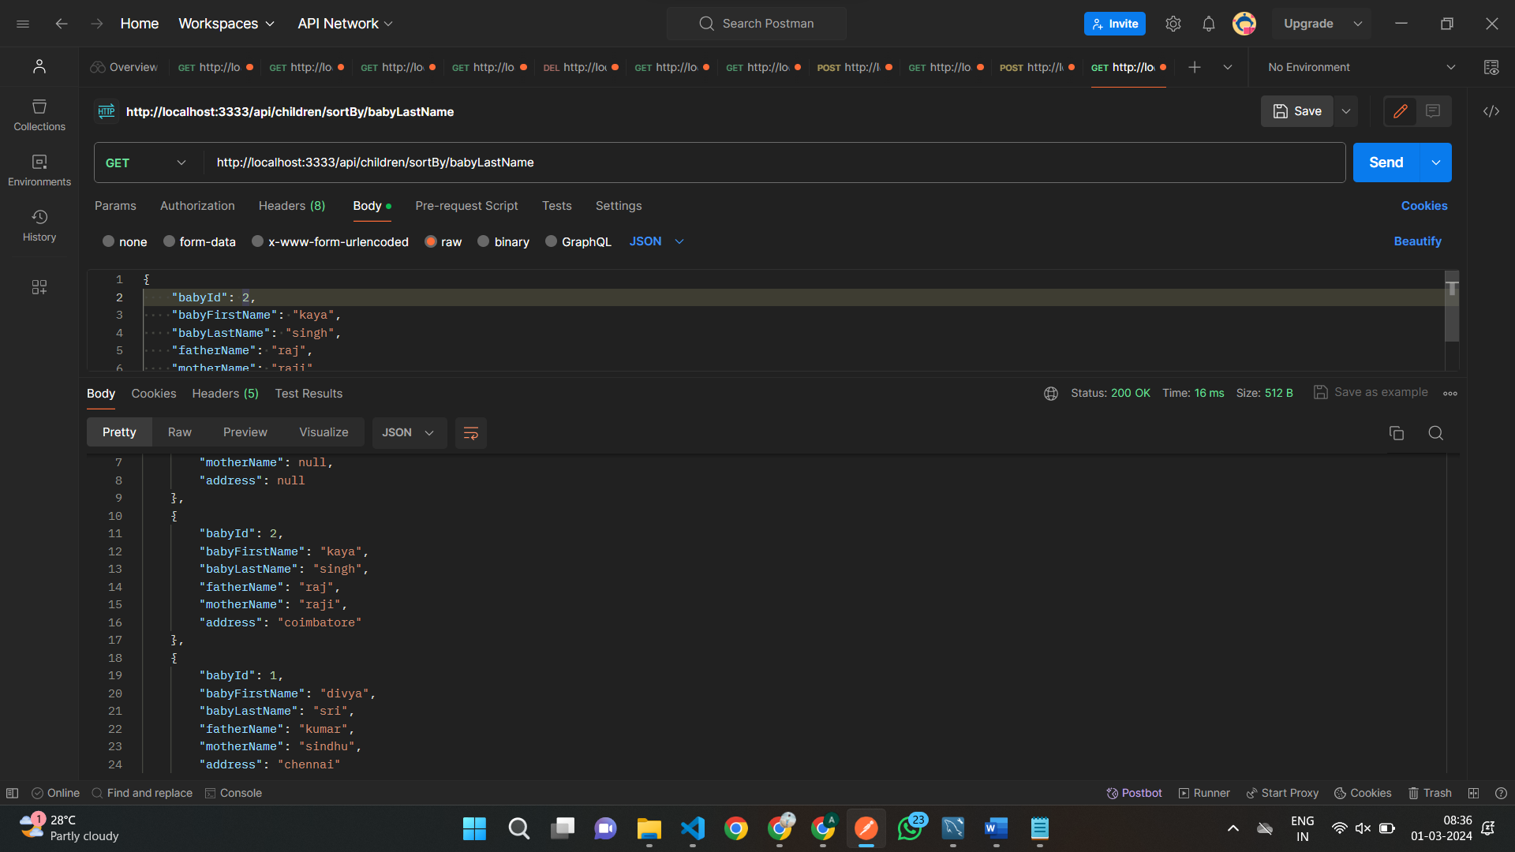

Class exercise 2

Get mapping by page no &page size

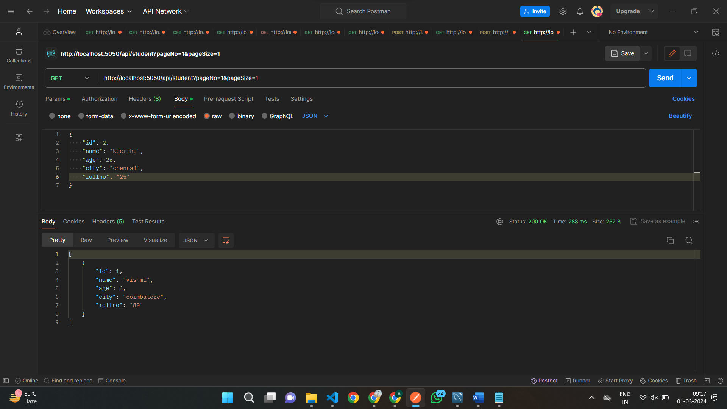

Post mapping

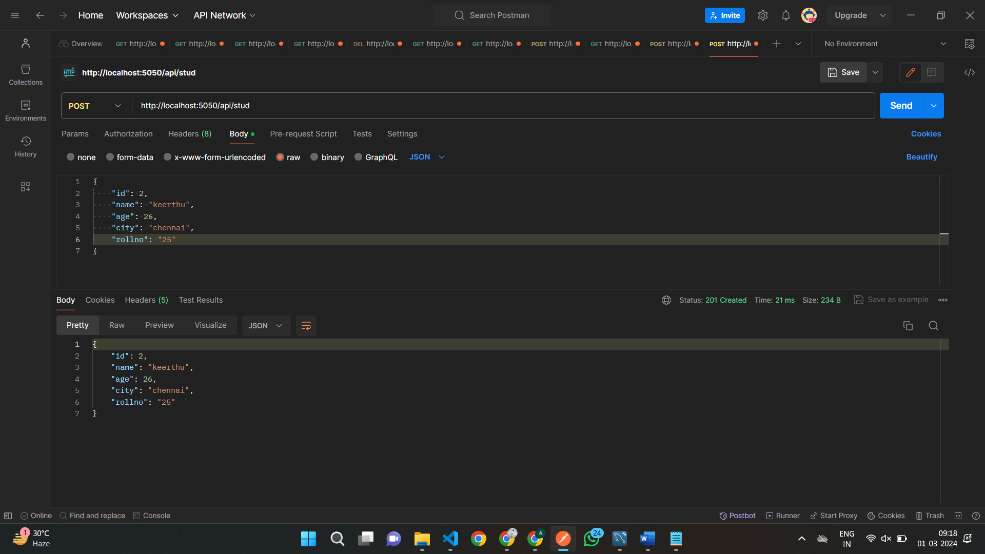

Get mapping by page no &page size and sorting name

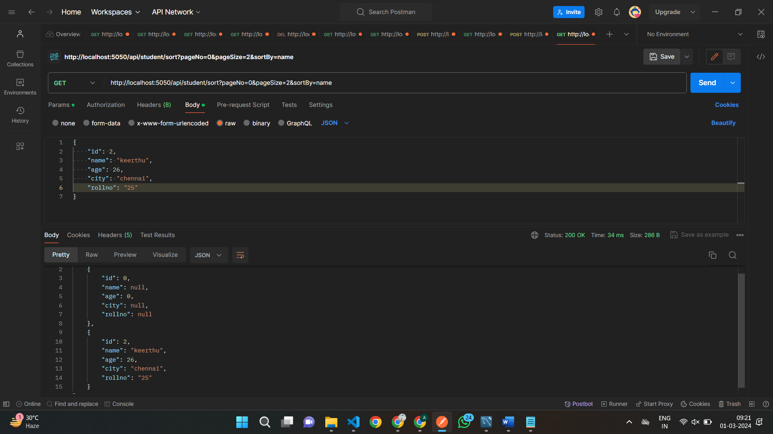

Class Exercise 3

Post mapping

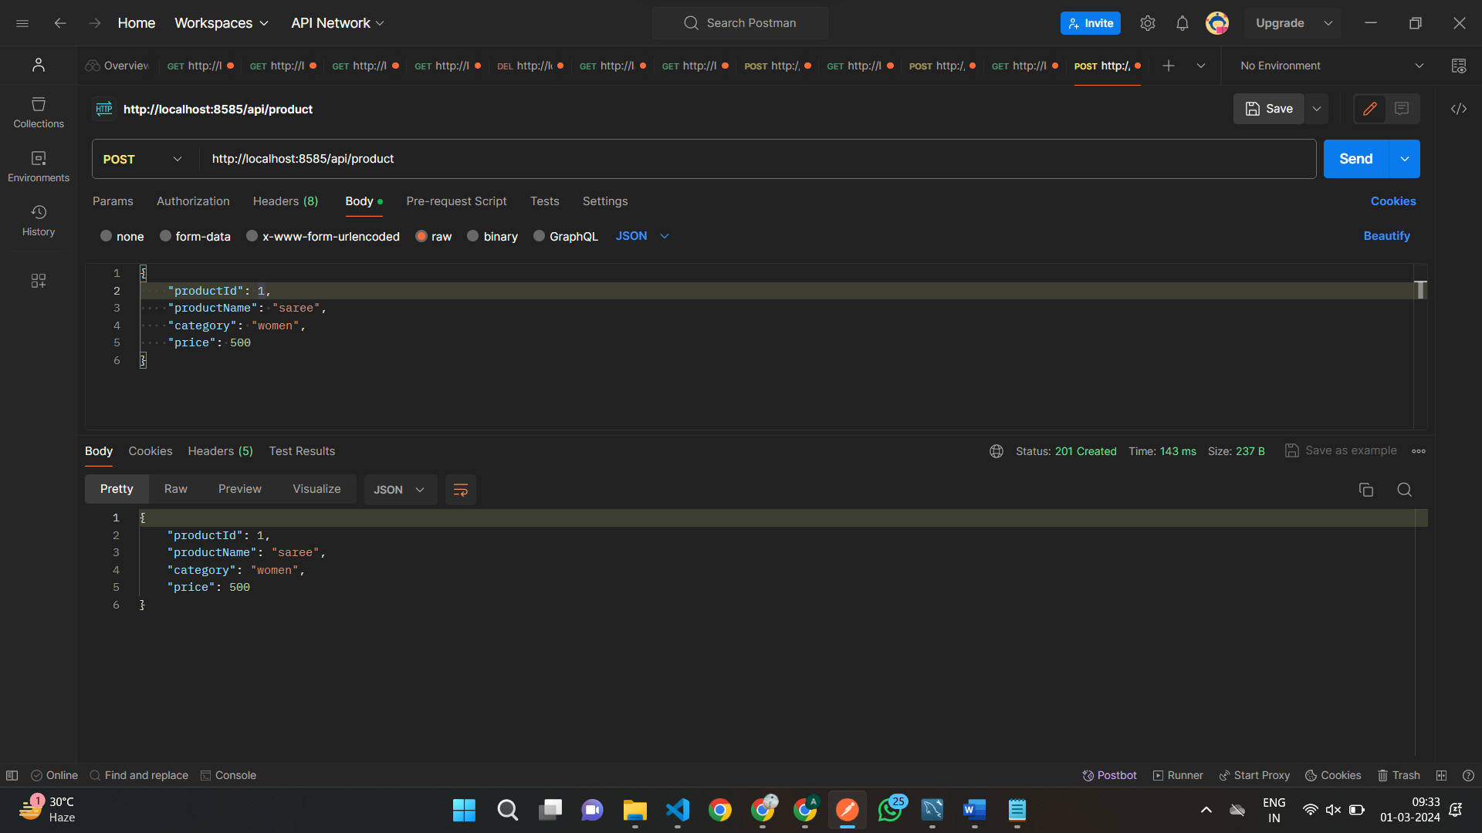

Get mapping by id

